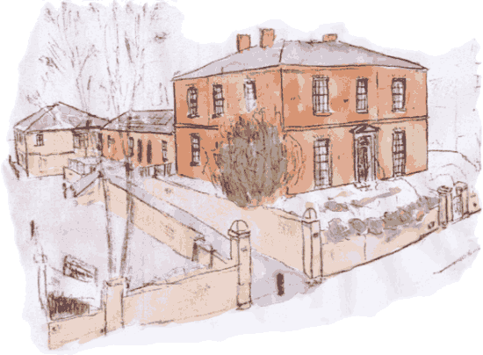
NORTH HOUSE SURGERY

Patient Participation Group
Minutes of Meeting on 29th January 2016
Attendees:
Patients –Alma Williams, Chris Backhouse, Frances Morgan-Rogers, Kathleen Wray, Mike Hartas, Jennifer Goodhand, Pauline Gaunt
Practice –Nigel Peacock (chair), Dr Sarah Moss

Apologies – Gill Braithwaite, Chris Bennett, Jennifer Jackson, Kate Swann, Margaret Grainger, Ruth Mason,
Practice –Nigel Peacock (chair), Dr Sarah Moss

1. Action from Previous Meeting
Gill Quinn from Dementia Forward will be running a training session with non-clinical staff in October.
Training was well received by staff, and one member has since volunteered to work for Dementia Forward. NP has advised the other practices in Harrogate and Rural District about the success of the sessions and some other practices are now having the same session.
Friends and Family Test Actions

Action: Nigel will add a comment to the website advising that for urgent appointments, patients should contact the surgery.
Completed – message added to the Home page on website.
Action: Further Communication of appointment system. Article to be included in the spring newsletter.
Action: Appointments Running Late. NP will continue to monitor

Patients Do not always like listening to radio Two in the waiting room.
Action: We now provide a mix between the radio and CDs

2. Staffing Changes
Dr Huber left the practice at the end of December. We have recruited an Advanced Nurse Practitioner, Carol Harrison who started on 4th January. Carol is full time and partly replaces Dr Huber was 0.5 full time. Carol will take some of the work previously done by GPs and her schedule will consist of initial telephone triaging of urgent care, minor illness clinics and Long Term Illness’ review clinics. The minor illness appointments will booked from her triage appointments. Jenny asked whether it will be possible for patients to pre-book these appointments, rather than having an initial triage.
Action – Nigel to consider the the feasibility of this.

3. Urgent Appointments
Patients needing to be seen on the same day, currently have to call the practices to book an initial triage telephone appointment. The practice is looking at the feasibility of making the triage appointments available on the internet booking system. NP gave an online demo of the process. Feedback from the group was positive, with the only comment on the use of the phrase “Telephone Triage” being confusing (some patients might not understand the phrase.
Action – NP to consider other wording and investigate further

4. On-line Access to Patient Records.
From 31st March 2016, we have to give patients the option of accessing their medical records on-line. This will include a summary of their current and past medical problems. NP gave a demo of the system. This was well received by the group and several members have volunteered to trial the system.

5. One Stop Shop (review of Long Term Conditions)
Nigel gave an overview of our system of recalling patients for the annual review of their long term conditions. Previously, if a patient had several conditions, then each one would be reviewed separately. For the past twelve months, our approach has been to review all the conditions at once, which reduced the number of times patients have to come to the practice and saves us appointments which can be used for urgent care.
Several members thought that the invite letter was a little confusing and it made reference to blood tests, even when tests weren’t require. NP will amend the invite letter to include comments.

6. Any Other Business
Electronic Prescribing System – MH mentioned that there is often a delay when collecting medication from Boots. One of the benefits of EPS is that medication should be ready by the time the patient get to the chemist. NP will raise concern at a forthcoming meeting with the local chemists.

Ripon Hospital and GP Practices – due to additional analysis of the needs of Ripon, there has been a delay to the submission of the Project Initiation Proposal. This is due to be submitted in March, and if approved the detailed Business Case will be submitted in November 2016. If full approval is give, the building will be operational by the end of 2018.

5. Next Meeting
The next meeting will be in the June/July

