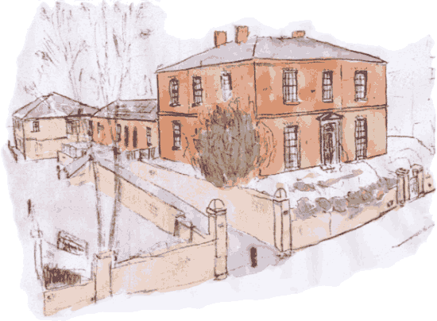
Please return to reception once completed
North House Surgery

If you are happy to join our Group by attending our meetings or periodical contact by e-mail or letter, please leave your details below and hand this form back to reception, indicating your preference.

I WISH TO BE INVOLVED IN THE NORTH HOUSE PATIENTS’ GROUP BY:
Attending meetings / email contact / postal contact (Please delete as appropriate)
Name
Address
Home Tel: Mobile Tel:
E-mail address:

This additional information will help to make sure we have a representative sample of patients that are registered with the practice:
Are you: Male Female

Age Group:
Under 16 16 – 24 years 25 – 34 years
35 – 44 years 45 – 54 years 55 – 64 years
65 – 74 years 75 – 84 years Over 84 years

To help us to ensure that our contact list is representative of the local community, please indicate which of the following ethnic background you would most closely identify with?
White
British Irish Other
Mixed
White & Black Caribbean White & Black African White & Asian
Asian or Asian British
Indian Pakistani Bangladeshi
Black or Black British
Caribbean African
Chinese or other ethnic group
Chinese Any Other Ethnic Group

How would you describe how often you come to the practice?
Regularly Occasionally Very rarely

Thank you

The information you supply us will be used lawfully, in accordance with the Data Protection Act 1998. This gives you the right to know what information is held about you, and sets out rules to make sure that this information is handled properly.

